Mark ANthony’s School of Cosmetology Scholarship Program
1st Quarter 2022
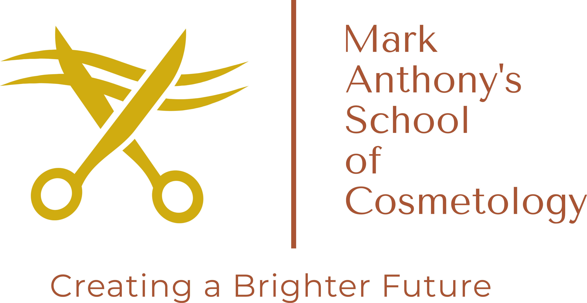 |  | Student applicant must:  - Be currently enrolled and be in good standing in the Cosmetology program at Mark Anthony’s School of Cosmetology  - Submit a Letter of Recommendation – ask an instructor or employer to vouch for your potential with a letter of recommendation.  - Submit a resume highlighting your skills, experience and what sets you apart.  - Submit two of your best pictures of your work to show off your skills.
All applications received will be evaluated and judged by an independent agent.

Winner will receive a Scholarship in the amount of $1000.00 credit toward the Tuition fees.
All materials for Q4 award must be submitted by 4:30pm
March 10, 2022
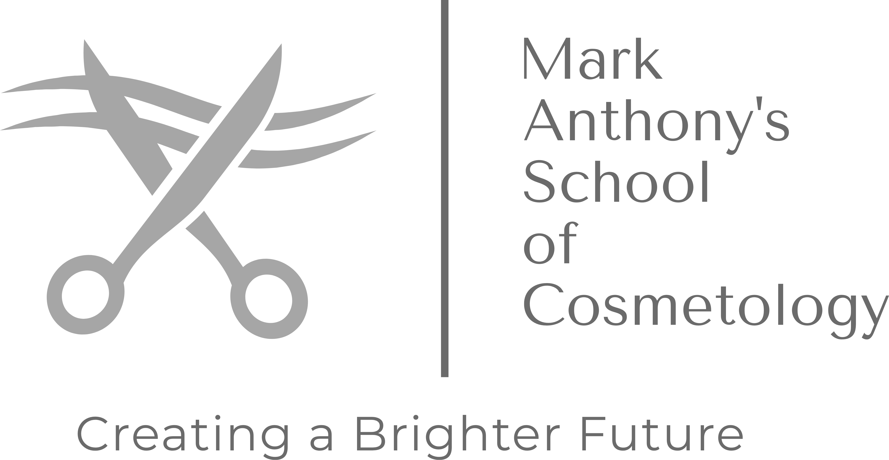 |  | Mark Anthony’s School of Cosmetology  1810 Shady Brook St, Columbia TN 38401  931-505-8386 386 | mark_anthonys@outlook.com | www.markanthonyssoc.com

